Using a Rotary Cutter

During this activity you will be cutting a piece of fabric into a 4” square.

All rotary cutters are essentially the same. Whether you use an ergonomic cutter with a 65 cm blade or a straight one with a 45 cm blade. The concepts are the same. Our goal is to cut a 4" square from a piece of denim. The same concepts, ruler placement, cutter use, etc., can be applied to cutting strips or other shapes. Use the cutting pad as the guide, but you may choose to use the lines on your ruler instead.

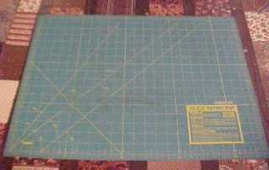  Our cutting mat is marked in 1" increments. It also has lines for bias cutting (the lines at 45 degree angles). Experiment with your mat and see what works best for you. If you do not have a cutting mat, use something underneath your fabric that will not a) dull the blade or b) be destroyed by the cutting. We highly recommend purchasing a cutting mat. | 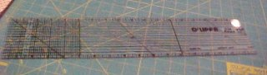  This ruler is 18" long and 4" wide, and marked in 1/4" increments. You can use any ruler you like for rotary cutting, but the measuring lines are helpful.  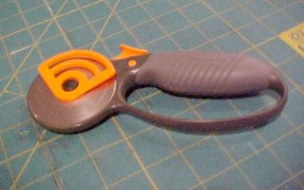This is an ergonomic cutter with a 65 cm blade.
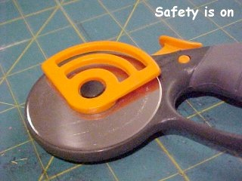  Almost all rotary cutters come with a "safety". It's usually a button that is pressed to engage the blade. In this photo, the blade is up, tucked into place, and not able to cut anything, including fingers. Do be careful, though, these blades are sharp! | 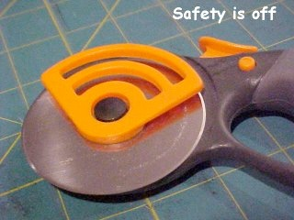  In this photo, the safety is off and the blade is ready to use for cutting. Note how it hangs a little over the edge. Be extra careful at this point.
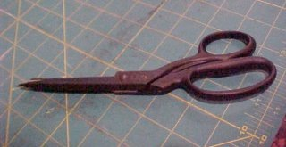  Have a good pair of sewing scissors handy to cut little bits that the rotary may have missed. We prefer to re-cut with scissors rather than the rotary cutter as the rotary blade sometimes cuts more than we mean it to. | 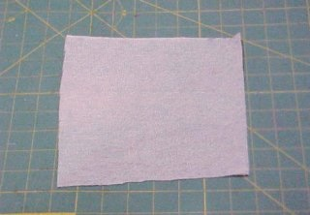  Take a piece of scrape fabric from the scrap box.
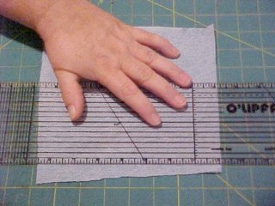  For edge 1 - place the fabric on the mat, match your ruler edges with the lines on the cutting mat. | 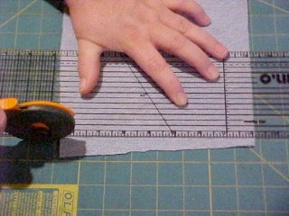  Move your hand out of the way, but maintain a firm pressure on the ruler. Engage the blade on the rotary cutter (safety off), and begin to cut along the edge of the ruler ... cut AWAY from your body.
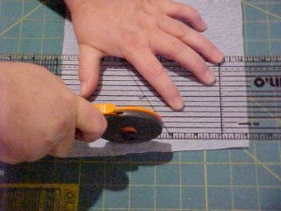  Continue along the ruler (which is being held in place on the guide marks on the mat). | 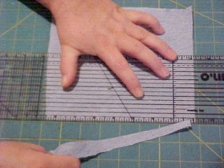  Continuing to cut away from you, cut through the end of the fabric along the ruler edge. Then remove the cut portion of the fabric. Discard.
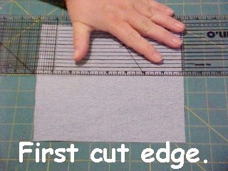  Leaving the fabric aligned with the mat, move your ruler over 4" (4 marks on the mat). Recall, our goal is a 4" square. | 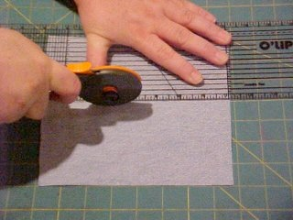  Again, align the ruler with the lines on the mat to assure a straight cut. Cut away from your body, holding your hand clear of the blade of the cutter, firmly keeping the ruler in place.
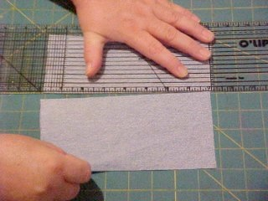  Remove the now 4" strip of fabric from the ruler's edge. | Turn the fabric 90 degrees and position on the mat such that it is aligned on the mat so we can cut the remaining 2 edges and have a 4" square.
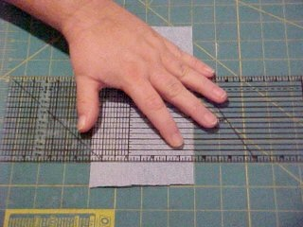  Align the ruler with marks on the mat. | 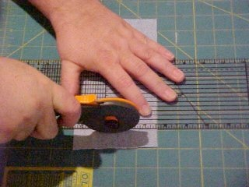  Repeat the cutting process, moving the cutter away from your body. The key is to cut the fabric while keeping the cutter close and sometimes touching the ruler without cutting the ruler itself.
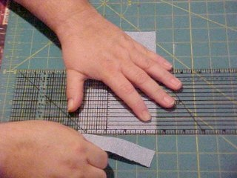  Remove the excess fabric. | 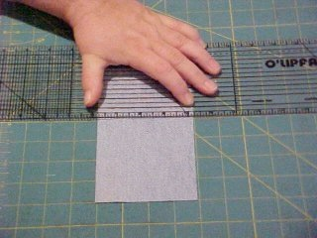  Reposition the ruler so that it is 4" (4 marks on the mat) away from the cut line.
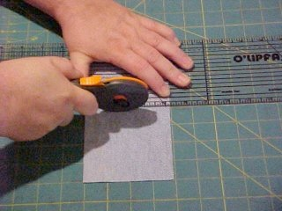  Cut away from your body as prior. | 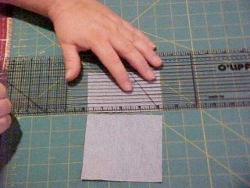  Remove the excess fabric and discard.

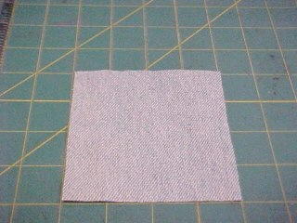
And now we have a 4" square piece of fabric that you can use in a quilt.
Check the square to verify that it is a 4” square.

Now you will need to cut 3 more 4” squares. Cut one more square from the fabric that you just made your first square from and using a second color of fabric cut two more squares..
Regardless of your use of the fabric that you cut with a rotary cutter, keep safety in mind at all times. Don't become too comfortable with your cutter; remember the safety features it comes with and use them.
Watch those fingers!

